**Chapter 5**

**Image Analysis and Filtering in the**

**Frequency Domain**

* The analysis of the previous chapters were made in the spatial domain in which the characteristics of the image and the masks were described in terms of (x,y) locations.
* In this chapter, we investigate images in frequency domain, which offers a powerful means for image understanding, enhancement and especially filtering.
* The ideas of smoothing by reducing high frequency contents or sharpening by increasing the magnitudes of high frequency components relative to the low frequency components come from the concepts directly related to image characterization in terms of its frequency contents.
* In fact the ideas of filtering discussed in Chapter 4 are considerably more appealing and intuitive in the frequency domain.

**5.1 Periodic Functions and Spatial Frequency**

A periodic function such as a sinusoid consists of a pattern or cycle that repeats in both positive and negative directions. The length of this cycle is called the period ***P***, and the reciprocal of the period denote by ***u*** is called the frequency. If the variation is in space (rather than for example in time), then P is the distance and ***u*** is the spatial frequency.

In addition to the frequency, a periodic variation is characterized by two other parameters –an amplitude A and a phase , as shown in Fig. 5.1. A one-dimensional image can be described by a gray level function

 (5.1)

where ***f(x)*** is the gray level, and u is the spatial frequency.

***P***

***f(x)***



                                      ******

                                                                                                    *** x***

Fig. 5.1 A sinusoidal variation of gray level.



* The sinusoid can be represented by an image, as shown in Fig. 5.2 where Fig. 5.2a shows a sinusoid with frequency of ***u = 4***, amplitude of ***A = 255,*** and phase of  = 0 on a 512 by 512 image. This means that the gray level values are now from 0 to 64. Note that there is no variation along the y axis. Figures 5.2b and 5.2c show, respectively higher frequency, and lower amplitude.

(a) (b) (c)

Fig. 5.2 (a) ***u = 4, A =255* ,** (b) ***u =8***, A =255 (c) u =4, A =63.

Fig. 5.3a and Fig 5.3b show the sinusoidal image with phase = 0, and  = 90 degrees, respectively. Fig 5.3c shows a sinusoidal image where the sinusoidal variations are in vertical direction. Finally Fig 5.3 (d) shows an image whose gray level values change along horizontal axis with a frequency of ***u = 8*** and along the vertical axis with a frequency of ***v = 4***.



1.  = 0, u=4, v =0 (b)  = 90, u = 4, v = 0 (c ) = 0, u=0 v = 4 

*v*

 = 0, u = 8, v =4 (d) *u*

Fig. 5.3 Various frequencies and amplitudes

* Image analysis in frequency domain is based on the fundamental work of Fourier. Fourier showed that any period function can be expressed as the sum of sine and cosine of various amplitudes and frequencies, i.e.

 ; $x=0,1, …, ∞$ (5.2)

where ***u*** is the number of cycles fitting into one period. Equation (5.2) is called the Fourier series.

For example, consider a square wave with a period of ***P =5*** given Fig. 5.4.

***f(x)***

+1

0 ***x***

-1

Fig. 5.4 A square function

It can be shown that the square function can be expressed as

; i = 1, 3, 5, … (5.3)

i.e. in (5.2)  for all ***u***, and  for odd i, for even u. The mean value of the above function is zero (why?). (verify that (5.3) is in fact a square function by calculating (5.3) up to i=20 and plotting it.

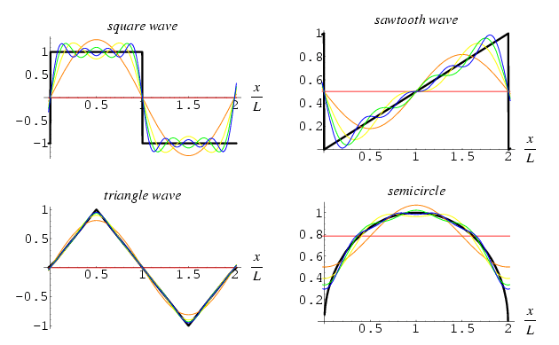

Fig. 5.5 Demonstration of Fourier series.

The Fourier series (5.2) can be also expressed for a function of two variables ***x***, and ***y*** as

 (5.4)

where ***u*** and ***v*** are the number of cycles fitting into a horizontal and a vertical period, respectively, and are called frequencies.

* Note that according to the Fourier series any image function ***f(x,y)*** can be decomposed (or represented) by a number of sine and cosine images (similar to those in Fig. 5. 2 and 5.3).
* In (5.4)  is the values of ***f(x,y)*** when ***u = v = 0*** (zero frequencies), that is the mean gray level of the image (why?).
* Higher values of frequencies ***u*** and ***v*** introduce fluctuations about this mean that are needed to represent gray level values across the image.
* The coefficients  and determine the relative contributions of each harmonics to the image, and provide useful information on the special frequencies that are present in the image.

**5.2 Fourier Transform**

Fourier transform provides useful information about the frequency contents of an image, and is used to filter the noise, which is associated with the high frequency components in an image.

**Complex Numbers:** Since Fourier transform involves complex numbers, we give a brief review. A complex number ***c*** has a real part ***a*** and an imaginary part ***b*** and is expressed as

 (5.5)

where . The complex number ***c*** has a magnitude ***r*** and a phase  given by (see Fig 5.4).

$$c1=a1+jb1$$

$$c2=a2+jb2$$

Imaginary axis



 (5.6)

***r b***



Real axis

Fig. 5.4 Complex number representation

Another useful representation of a complex number is in the form of an exponential



$c1*c2=r1*r2{*e}^{j(φ1+φ2)}$ $\frac{c1}{c2}=r1/r2{*e}^{j(φ1-φ2)}$

Using the Euler formula , we get from (5.6) and (5.7)

 and .

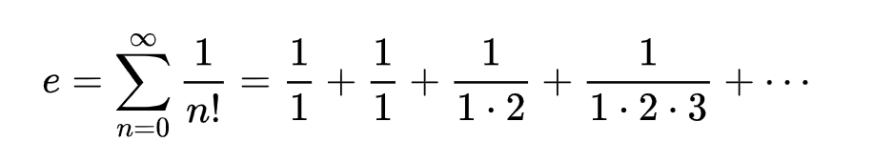

Euler (or natural) number $e=2.712828⋯$

If $φ=π=3.141592⋯$**then**

$$e^{jπ}+1=0$$

Note binary 0 and 1. **This is called the most beautiful math equation!**

Furthermore, Euler formula allows us to express cosine and sine of an angle in terms of itself, i.e. we have (why?)

 and  (5.8)

* We now consider Fourier transform along x-axis only, i.e. one-dimensional transform. Let ***f(x)*** be the gray levels at x = 0, 1, 2, …, n –1. The Fourier transform is defined as

; ***u = 0, 1, 2,…, n-1*** (5.9)

where ***u*** is the frequency along horizontal axis. Note that ***F(u)*** is only a function of ***u*** (not ***x)***.

**Example 1**: Consider ***f(x)*** as shown in Fig. 5.6 below where there are only 4 pixels across x axis and their gray level is 120.

***f(x)***

***120***

Fig. 5.6 An image

Function f(x) = **120 120 120 120**

***0 1 2 3 x* 0 1 2 3**

The Fourier transform of ***f(x)*** is computed from (5.9) as





***F(u)***

Fig. 5.6b Fourier Transform

of f(x) = 120 120 F(u)= 120 0 0 0

u= 0 1 2 3

1. u

(Using Euler formula verify that the last expression is in fact zero). Similarly it can be shown that ***F(2) = F(3) = 0*** (why?). The Fourier transform is shown in Fig. 5.6b, and it is seen that it has only one component, which is at the zero frequency. This is meaningful since the gray level values are constant across the image (Fig. 5.6), and there is no variation. This result can be generalized to one-dimensional images having any number of pixels (in general n), e.g. if  ***f(x) = l*** , for ***x = 0, 1, 2, …, n*** then ***F(u) = l*** for ***u = 0***, and ***F(u) = 0*** for ***u = 1, 2, …, n-1*** (why?).

**Example 2**: Suppose that the image has one bright pixel with gray level ***l*** at ***x = 0***, and all other pixels are black, i.e.



***f(x)***

***120***

Fig. 5.6 An image

Function f(x)= 120 0 0 0

***0 1 2 3 x*** *x=* 0 **1 2 3**

The Fourier transform of the above image is obtained from (5.9) as

 for ***u =0,1,…, n-1***

The Fourier transform is plotted in Fig 5.7, and it has all frequency components (what is the explanation for this behavior?).

***F(u)*** F(u)

u= 1 2 3 4

Fig. 5.7 Fourier Transform

of ***f(0) = l***, and ***f(x) =0***

otherwise.  ***l/n***

***0 1 2 3 … n-1 u***

f(x)

In general Fourier transform has both real and imaginary parts as the following example demonstrates.

***Example 3***: Consider the image function ***f(x) = l00*** for ***x = 0, 1*** and ***f(x) = 0*** for ***x = 2, 3***. The Fourier transform is computed from (5.9), which after simplification gives (why?) 100 100 0 0

**0 1 2 3**

***F(0) = 50, F(1) = 25 – j25, F(2) = 0*** and ***F(3) = 25+ 25j***.

The magnitude is computed from (5.6) as

|***F(0)| = 50, |F(1)| = 35.5, |F(2)| = 0*** and |***F(3)| = 35.5***

50 35 0 35

The phase can also be computed using (5.6).

0 1 2 3

**Note:** Slowly changing gray levels in spatial domain tend to result in low frequency components in Frequency domain, whereas abruptly changing gray levels in spatial domain cause in have high components in frequency domain.

* If the Fourier transform ***F(u)*** is given and the image ***f(x)*** is to be found, then we use the ***inverse Fourier transform*** given by

 ; ***x=0, 1, 2, …, n –1*** (5.10)

; ***u = 0, 1, 2,…, n***

Note the similarity between (5.9) repeated above and (5.10).

**Example 4**: Let ***F(0) = 120***, and ***F(u) = 0*** for ***u = 1,2,.., n –***1. The inverse Fourier transform is



Similarly, the other components are found to be (why?) ***f(1) =f(2) =f(3) =120*** which are expected (why?).

* In general image are two dimensional ***f(x,y)***. In this case the Fourier transform is

 (5.11)

where ***v*** is the frequency along vertical axis. In case the image is not square, ***n*** must be replaced by height ***h*** and width ***w***.

The inverse Fourier transform for the two dimension image is

 (5.12)

**Spectra of an Image**: Since ***F(u,v)*** is a complex quantity, we can write it as

***F(u,v) = R(u,v) + j I(u,v)*** (5.13)

Where ***R(u,v)*** and ***I(u, v)*** are the real and imaginary parts of ***F(u,v)***. The following two quantities are important:

Amplitude spectrum:  .

Phase spectrum: .

Power spectrum : 

The phase spectrum is less significant than the amplitude spectrum for image analysis.

**Spectra Display**

The spectrum amplitude ***|F(u,v)|*** is generally displayed as an 8-bit gray level image. Therefore a scaling is usually done to bring the value of |***F(u,v)|*** to the range of 0 to 255. Natural (non-synthetic) images mostly contain low frequency components which are concentrated around u = v = 0 in the center of the spectrum image with few higher frequency components. This results in a situation where most of the display window is black with heavy concentration of light pixels are in the center. In order to better view this high activity region, a logarithmic mapping of the following form is applied

 (5.23)

where the constant C is chosen so that the results is an 8-bit value. The +1 is for preventing the case of undefined logarithm when ***|F(u,v)|=0.***

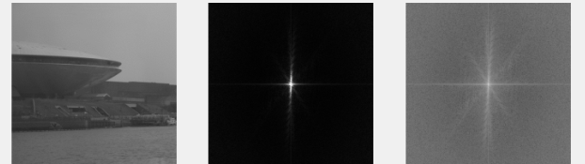

1. (b) (c)

Fig. 5.7 (a)Original image, (b) Spectrum with contrast enhancement, (c) Log spectrum

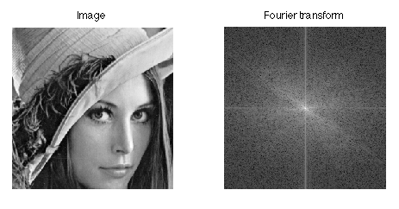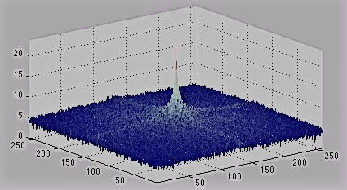

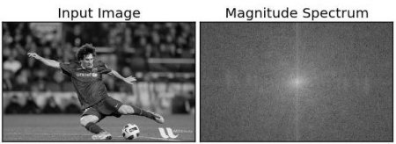

Fig. 5.8-5.9 Image and its Fourier spectrum (log magnitude).

Let us now examine a few synthetic and natural images. Figure 5.10 shows step type images, one with 2-step (half black, half white), and the other a 64-step image. The amplitude spectrum of the each image is shown below it. Note that because of abrupt change along ***x*** direction of ***f(x,y)*** in Fig. 5.10a, the spectrum 5.10c contains a lot of both low and high frequency along the ***u*** axis in **|*F(u,v)|*** plane. The image 5.10b has a slow variations in gray levels along the ***u*** axis, and therefore its spectrum has lower amplitudes (seen as low gray levels) along the ***u*** axis in Fig. 5.10d. However, because of the periodic nature of the 64-step image, we now observe some relatively strong components at several locations along the ***u*** axis in Fig. 5.10d.

(a) (b)

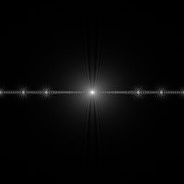 (c) (d)

Fig. 5.10 (a) Binary 2-step image, (b) gray level 64-step image, (c) Spectrum of (a), and (d) spectrum of (b).

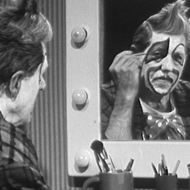

**Clown f(x,y)**

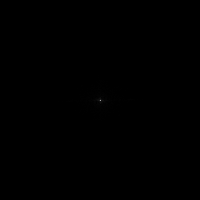 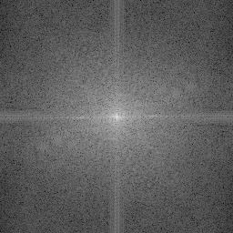

**Clown |F(u,v)| Clown log|F(u,v)+1|** 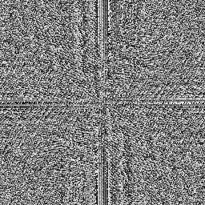 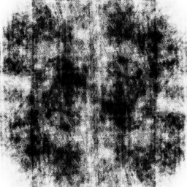

**Clown**  **Clown Inv |F(u,v)| (without phase).**

Fig. 5.11 The effect of phase on inverse Fourier transform

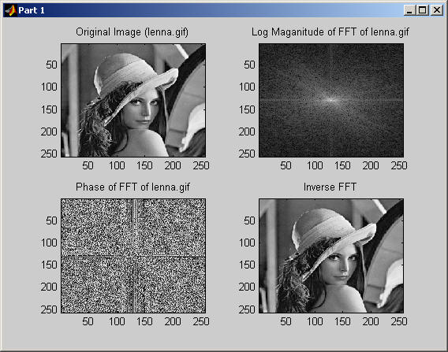

**Fig. 5.12 Fourier spectrum and phase and its inverse.**

**5.3 Properties of Fourier Transform**

Here we mention several useful properties of the Fourier transform:

**Separability**: A two-dimensional (2-D) Fourier transform can be computed as two 1-D transforms since (5.11) can be written as (why?)

 (5.11)

 (5.14)

where the second summation is in fact a 1-D transform on ***f(x,y)*** along the vertical axis. We denote the second summation by ***F(x,u***), (why is the second summation a function of ***x*** and ***v*** only?) and write (5.14) as

 (5.15)

Note that (5.15) is another 1-D transform. Therefore instead of writing a program to compute a 2-D Fourier transform, we write a simpler program for a 1-D transform and run it twice with different arguments (why is it better to do two 1-D transforms instead of one 2-D transform?). The same principles of separability applies to the inverse Fourier transform (why?).

**(b) Periodicity and Symmetry**: the Fourier transform and its inverse are periodic functions with the period ***n*** since

***F(u,v) = F(u+n, v) = F(u, v+n) = F(u+n, v+n)*** (5.16)

(Verify the above by replacing ***u*** with ***u+n*** in (5.11), and similarly with **v+n**, etc.) This property implies that only one period (***0 to n-1***) is needed to completely specify ***F(u,v)*** (why?). Furthermore, ***F(u,v)*** is symmetric since

***| F(u,v) | = | F(-u, -v) |*** (5.17)

(why?) To see the implications of periodicity and symmetry, for simplicity consider the case of 1-D transform in which (5.16) and (5.17) simplify to

***F(u) = F(u+n)***  and ***| F(u) | = | F(-u) |***  (5.18)

***| F(u)|***

***- n/2 0 n/2 n –1***  u

one period

Fig. 5.13 Periodic and symmetric nature of the Fourier transform

Since Fourier transform is formulated in the interval 0 to n-1, the result produces to “back to back” half periods. To display a full period with the maximum value at the center (rather than at either side of the display frame), we must move the origin to ***u = n/2*** as shown in Fig. 5.14.

***| F(u)|***

***-n/2 0 n /2 n –1*** u

one period

Fig. 5.14 The original is shifted to u = n/2.

Fig. 5.15 show the concept of periodicity and symmetry in 2-D as an image. Note that when the origin is unchanged the Fourier transform image appears in four corners of the u-v display plane, as shown by a solid line square. In order to bring the Fourier transform image to the center of the display, F(u,v) must be shifted to u = n/2 and v = n/2, as shown by the dotted square

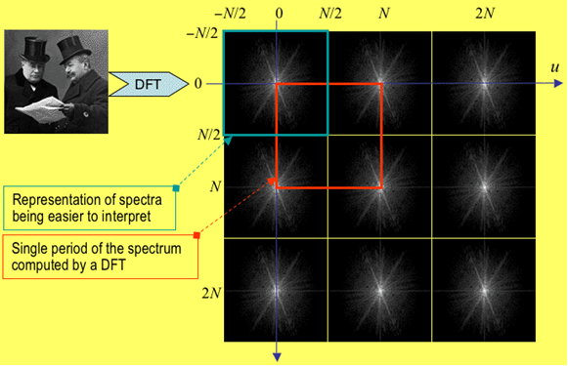

Fig. 5.16 Fourier transform shifting the origin u=0, v=0 to

u=N/2, v=N/2..

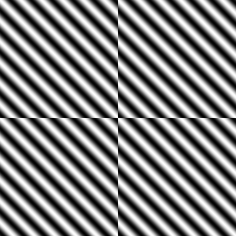

**Strip as seen by FT**

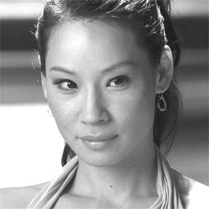





Fig. 5.17Image as seen by the Fourier Transform

To implement the shift, we must determine the value of ***F(u –n/2, v –n/2)*** using (5.11)as follows (verify this):



The above equation implies that in order to shift the origin of the **F(u,v)**, we must first multiply the image function ***f(x,y)*** by and then perform the Fourier transform. This simply means that when ***(x+y)*** is odd, we change ***f(x,y)*** to ***– f(x,y)***, otherwise we leave it unchanged.

**5.4 The Fast Fourier Transform (FFT)**

The computation of a 2-D Fourier transform, require two 1-D transforms. A 1-D transform involves determining for each ***u.***  This require ***n*** complex number multiplication of the exponential by **f(x)** plus ***n –1*** additions for each u, with the total complexity of , (why?). Note that  can be computed once and be kept in an array (what will be the size of this array considering that there are ***n*** values for ***u*** and ***x***?)

Using FFT, the number of multiplication and additions will reduces to . This is a considerable saving, e.g for ***n = 512***,  whereas , and ***for n = 1024***,  versus .

For 2-D images, the complexity becomes $O(n^{4})$. Because of separability of and other FT properties, we can do it in $O(n lg n)$. For n=1000, $n^{4}={10}^{12}$.

* To perform an FFT, we require ***n*** to be a power of 2 and the image to be square. In case the image is not square, we pad it with zeros (black) to get the required size. A 1-D FFT of length ***n*** is performed by two FFTs of length n/2 each, as follows

(5.19)

(Why? - verify the above for ***n=4***). Furthermore, we can write (5.19) as



where  is a constant complex number (verify the above). The above equation shows that the FFT contains two parts – one uses only even ***x*** and the other uses odd ***x***. In other words

 (5.20)

Furthermore, FFT can be computed recursively, as follows.

 ***n***

 ***n/2***

  n/4

     ***n/8***

For example if n = 16, then

 uses ***f(0), f(2), f(4), f(6), f(8), f(10), f(12), f(14)***

 uses ***f(1), f(3), f(5), f(7), f(9), f(11), f(13), f(15)***

 uses ***f(0), f(4), f(8), f(12)***

 uses ***f(2), f(6), f(10), f(14)***

 uses ***f(0), f(8)***

 uses ***f(4), f(12)***

If n is a power of 2, then due to the recursive nature of the FFT algorithm its complexity becomes ***O(nlg n)***, (why?).

**Bit Reversal** : In order to determine which image data ***f(x)*** is to be used for ,,, , etc., we perform bit reversal, as the following table demonstrates

array binary bit array

index representation reversal index

0 0000 0000 0

1 0001 1000 8 

2 0010 0100 4

3 0011 1100 12

4 0100 0010 2

5 0101 1010 10

6 0110 0110 6

7 0111 1110 14

   

15 1111 1111 15

Note that the bit reversal allows combining correct sequences for performing FFT. Thus before carrying out the FFT, the image function ***f(x)*** must be reordered so that the resulting FFT is correct.

Note: Fourier transform and its inverse are different only in the sign of exponential, and therefore the same method can be used to perform both forward and inverse transform by supplying an argument –1 for the former and +1 for the latter.

**Fourier Array**: The FFT of ***f(x)***, ***x=0,1, …, n-1*** is stored in a 1-D array of size 2n since each value of F(u) has a real and an imaginary part. The real and imaginary parts are stored in consecutive array locations, i.e. Real (F(u)) is stored in Fourier array FA[2u], and Imaginary(F(u)) is stored in Fourier array FA[2u+1], u = 0, 1,…, n-1. Although the image function f(x) is real, we allocate an Image array IA of size 2n, and fill its alternate locations with f(x). The odd number locations are set to zero. This allows the same function to be used for both forward and inverse transforms. Note 2-D transform is in fact two 1-D transforms as noted previously.

The code below performs bit reversal for an array A of size 2n, where the real parts are stored in even indexed elements and imaginary parts are stored in odd indexed array elements.

void BitReversal(double* A, unsigned long n)

{

unsigned long n, p, i,k;

k=1;

for (i=1; i<n; i+=2) {

if (k>i) {

swap(A[k-1], A[i-1]); //in place swapping of real array elements,

swap(A[k], A[i]); // swapping of imaginary parts.

}

p = n;

while (p>=2 && k>p) {

k -= p;

p >>= 1; }

k += p;

};

}

**Exercise**: Trace the above code for n=8 and verify that the returned array has correct ordering, i.e. is bit-reversed.

***Windowing Effect***: Fourier transform F(u,v) is periodic, and implicit in this periodicity is that the image f(x,y) is also periodic. Therefore when an image array of size ***n*** by ***n*** is presented to the Fourier transform, it assumes that ***f(x,y)*** repeats its self as shown in Fig. 5.18

As seen there are discontinuities at the borders, and the Fourier transform sees it as a sudden change in the image and accommodates it through distortion of the spectrum. This effect is called windowing since FFT is presented with a window, and not as it expects with a plane extending to infinity in all directions.







Fig. 5.18 Spatial discontinuities at borders due to periodic assumption

The windowing effect is reduced by smoothing the image at edges. A number of smoothing functions have been presented. Barlett proposes that the image ***f(x,y)*** be multiplied by the following function before taking the FFT. $r=\sqrt{x^{2}+y^{2} }$

 (5.21)

where $r=\sqrt{x^{2}+y^{2} }$ $f\left(x,y\right)$ is the distance from the center of the image, and is its maximum value. This function has a cone shape. The Hanning window is defined by

 (5.22)

Hanning window is somewhat smoother than Barlett window.

* 1. **Matlab Implementation of FFT**

Matlab has a number of functions for FFT, as follows:

***fft*** takes the discrete fast Fourier transform (DFT) of a vector.

***ifft***take the inverse DFT of a vector.

***fft2*** takes DFT of a matrix

**ifft2** takes inverse DFT of a matrix

**fftshift** shifts the origin of DFT to the center of the display as discussed in the previous section.

Example; suppose we create a box white square inside a black background using

*>> A=zeros(256,256);*

*>> A(80:180,80:180)=1;*

*>> imshow(A)*

*>> Afft=fftshift(fft2(A));*

*>> figure, imshow(mat2gray(log(1+abs(Afft))))*

The results are shown in the figure below:

 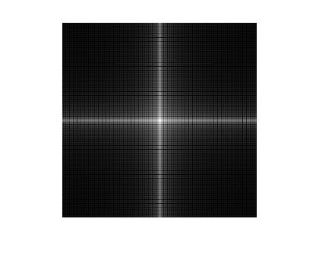

1. Image (b) FFT

Fig. 5.15 The synthetic image and its Fourier transform.

Note that sudden changes in the image values at the white square borders have created many frequencies in both horizontal (u) and vertical (v) directions.

**Example**: The code creates a small white circle with a radius of r =15, and its fft:

*>> [x,y]=meshgrid(-128:127.-128:127);*

*>> r=sqrt(x.^2+y.^2);*

*>> circle=(r<15);*

*>> circlefft=fftshift(fft2(circle));*

*>> imshow(mat2gray(log(1+abs(circlefft))))*

The circle fft is shown below and exhibits many frequencies because of sudden changes. Now if we smooth the circle so that it does not have sharp edges we get the low frequency circle fft.

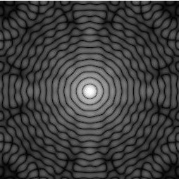 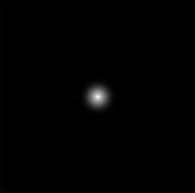

(a) (b)

Fig. 5.16 (a) FFT of a circle (disk), and (b) FFT of a smooth circle (disk)

* 1. **Power Spectrum and Image Information Contents**

A natural image contains many frequency components, i.e. from low to high values of ***u*** and ***v***. However, the low frequency components generally have higher magnitudes, and many high frequency components are usually absent in a natural image.

* To demonstrate this fact consider the 300450 image given in Fig. 5.17a. This image is now padded with zeros to make it a 512512 = 266144 pixel image (why?). Suppose now that we perform Fourier transform on this padded image, and only retain components that are approximately in a circle of 125 pixel radius around the origin in the u-v plane. We then set the remaining components approximately to zero (this is called a Butterworth low pass filter to be discussed shortly).
* This way we are raining only (1251253.14)/( 512512) = 18.7% of the frequency information. Fig. 21b shows the image after the inverse transformation. Despite the fact that more than 80% of the frequency domain information is removed, we see little degradation in the quality of the image.

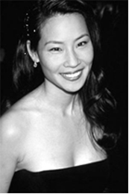  

(a) (b) (c)

Fig. 5.17 (a) Original 300450 pixel image, (b) 512512 Fourier transform, (c) Image after removing more than 80% of frequency components.

The image information contents are related to the power spectrum defined as

Power spectrum :

$P\left(u,v\right)=\left|F(u,v)^{2}\right|=R^{2}\left(u,v\right)+I^{2}\left(u,v\right)$ (5.23)

The total power is sum of power spectrum over all frequencies

$P_{tot}=\sum_{u=0}^{n-1}{\sum_{v=0}^{n-1}{P\left(u,v\right)}}$ (5.24)

If we choose to keep only the power in a circle of radius $r_{0}$, called cut-off frequency, we will keep only a fraction of information contents. The following example clarifies this point. The power determines the radius or cutoff frequency .

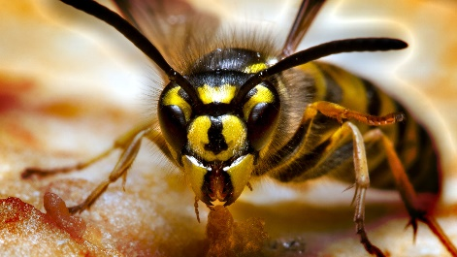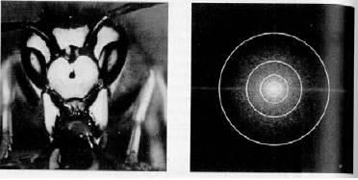 

Fig. 5.18 An image and its Fourier spactrum with various radiaii .

Most of the total power (representing information) is at low frequencies in a natural image. Fig. 5.19 demonstrates this fact for different radii and power.

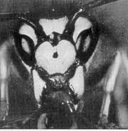 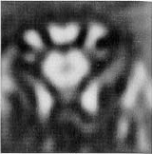 

450x450,=100% =8, =90% =18. =93%

  

=43, =95% =78, =99% =152, =99.5%

Fig. 5.19 The relationship between cutoff frequency and total power .

* 1. **Frequency-Domain Filtering**

* In the previous chapter we discussed several filtering techniques in the spatial domain to reduce noise and improve the quality of the image.
* Filtering in frequency domain is more effective for many types of noise where spatial domain filtering cannot achieve good results, such as Gaussian noise.
* More importantly, noise is best described as high a frequency signal and therefore the frequency domain techniques are more appropriate to describe and filter the noise.
* Finally, convolution in spatial domain is computationally more expensive than filtering the in frequency domain (why?).
* Filtering can be expressed as the pixel by pixel multiplication of the spectrum ***F(u,v)*** by the filter (mask) transfer function ***H(u,v)***

***G(u,v) = F(u,v) H(u,v)***

where ***G(u,v)*** is the output image.

* The filter transfer function ***H(u,v)*** must be specified to achieve a particular filtering objective, as we shall see.
* Most filters are zero-phase-shifters, meaning that they do not change the phase of the image.
* A fundamental relation exists between filtering in the spatial and frequency domains, which can be expressed as follows:

**Fourier( *f(x,y) © h(x,y) ) = F(u,v) H(u,v)***  (5.25)

**InvFourier(*F(u,v) H(u,v)) = f(x,y) © h(x,y)***

* This relation which we have quoted without proof, states that if the image ***f(x,y)*** is convolved with the mask (filter) ***H(x,y)*** and then Fourier transform is taken, the result will be equal to multiplication of the Fourier transform of the image by th e Fourier transform of the filter. Similarly the inverse Fourier transform of the product is equal to the convolution. As a result, everything that can be achieved in the spatial domain, can be obtained in frequency domain, and vice versa.
* It turn out, however, that performing the operations in the frequency domain is computationally more efficient (require less operations) than in the spatial domain, when the dimension of the filter is high (e.g. higher than 5 by 5).
* However, the main reason for working in the frequency domain is that in many cases much better filtering can be achieved (why?)

**5.7.1 Procedures in Filtering**

The steps of filtering is shown in Fig. 5.19. First we need to define a filter. The filter can be defined in spatial domain h(x,y) or frequency domain H(u,v).

**Case 1- Frequency Domain Filter:** The following steps are performed for the given the filter *H(u,v)* and the image *f(x,y)*.

1. Pad the image of size , with zeros to get an image of size where n is a power of 2 and a number closest to *max(w,h*). Call the padded image .
2. Multiply by  to obtain 
3. Compute the FFT of  to get 
4. Create the filter *H(u,v)* of size and multiply it bypixel wise to obtain the filtered image .
5. Take the inverse of to get the filtered image
6. Extract the  image by taking the  pixels from the left corner of .

The above procedure is shown in Fig. 5.20

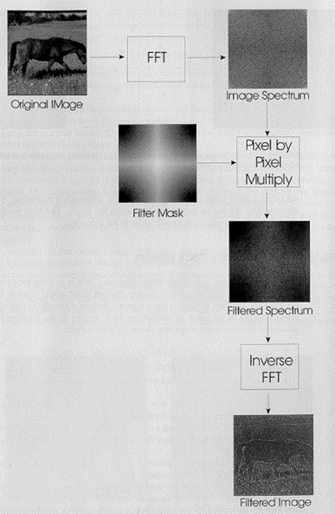

Fig. 5.20 Steps in filtering. Note that the image size is assumed to be a powers of 2.

An example of the filtering is shown in Fig. 5.21.



*g (x,y)*

*f (x,y)*

*g1(x,y)*

*G1 (u,v)=F1(u,v)H(u,v)*

*H(u,v)*

*F1(u,v)*

*f1(x,y)=f0f(x,y)(-1)x+y*

*f0(x,y)*

*f (x,y)*

Fig. 5.21 Various stages of filtering.

**Case 2- Special Domain Mask**

In this case we first find the Fourier transform of the filter as follows:

1. Multiply, pad it with zero to get the size of the image (in power 2)
2. Multiplyby  to obtain 
3. Take the Fourier transform of to get *H(u,v).*
4. Continue as in Case 1.

**5.7.2 Low Pass Filtering**

Noise is usually reflected in an image as high frequency components, and thus the purpose of a low pass filter is the remove such frequencies to clean the image. An ideal low pass filter has the following characteristics

 (5.26)

where and is  constant. Equation (5.26) describes a circle in the ***u-v*** plan with a radius of . When the above filter *H(u,v)* is multiplied by the image Fourier transform *F(u,v),* the frequency components inside the circle, which correspond to low frequencies, remain unchanged in the output image, and the component outside the circle are removed. The frequency  is called the cut off frequency, and is specified by the user, e.g. in Fig 5.21, .

Fig. 5.22 shows another representation of (5.26)

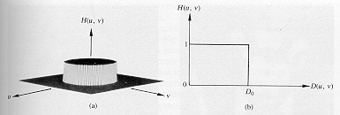

Fig. 5.22 A representation of the ideal low pass filter.

An ideal low pass filter blurs the image as result of removing higher frequencies. It has also another side effect and that is a phenomenon called ringing. The ringing effect is due to sharp and sudden change in the filter characteristics, as evident from Fig. 5.22

We know from (5.25) that multiplication in the frequency domain is equivalent to convolution is spatial domain. Now the spatial domain characteristics of and ideal low pass filter is of the form  which is the equation of a wave (ripple). When this wave (called the sinc function) is convolved with the image, it produces the so called ringing effect. The ringing phenomenon is illustrated in Fig. 5.23.

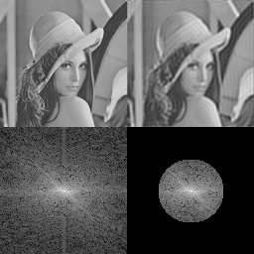

Fig. 5.23 The ringing effect due to sharp and sudden cutoff frequency.

In order to remedy the ringing effect, two smooth filters are available, Butterworth and Gaussian low pass filters.

**5.7.3 Butterworth Low Pass Filter**

The characteristics of this filter is such that it gradually attenuates the high frequency.

;  (5.27)

where *p* is the order of the filter.

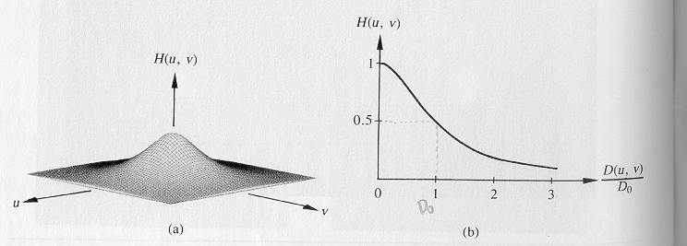

Fig. 5.24 Characteristics of the low Butterworth low pass filter; note that in this figure .

The effect of *p* is shown in Fig. 5.25. It is seen as *p* increases the filter becomes sharper.



*p*=4

*p*=1

*p*=16

n=1

n=1

Fig. 5.25 The effect of filter order on filter characteristics

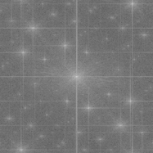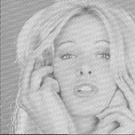

*Fig. 26*(a) (b)

Fig. 5. 26a shows an image corrupted by sinusoidal noise, where the Fourier spectrum is seen in Fig. 5.26b and shows the high frequency contents of the noise. Fig. 5.27a shows the image after applying a Butterworth low pass filter of order 2. Finally, Fig. 5.27b is the Fourier spectrum of the filtered image. As seen, the high frequency components are removed.

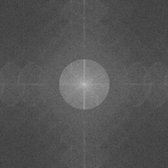

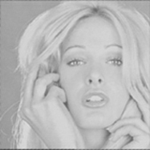 (a) (b)

Fig. 27 The result of low pass Buttterworth Filter

Note that a mean or median filter will not be effective in case of sinusoidal noise, as the former just averages the noise and the signal (clean part of image), and the latter can pick many noise pixels. Fig. 5.28 shows that neither of these spatial domain filters is effective in reducing the noise which has spread through the fabric of the image.

(a) (b)

Fig. 5.28 (a) The result of mean filtering of the sinusoidal noise corrupted image of Fig. 26(a), image (b) median filtering of the image in Fig. 5.26a.

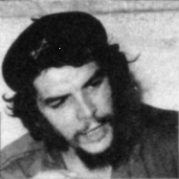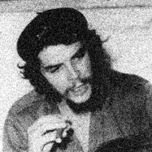Finally, Fig. 5.29 shows Butherworth low pass filtering of an image corrupted by the Gaussian noise. The image is taken many years ago with a low quality camera and under adverse environmental conditions (possibly cloudy and rainy weather). Note that the filtered image is zoomed in to show the details.

5.30 (a) Image with Gaussian noise (b) Butterworth filtered.

**5.7.4 Comparison of Ideal and Butterworth Low Pass Filters**

Fig. 5.31(a) shows the result of ideal filtering of top right image with filters of various cutoff frequencies, of = 10, 30, 60, 160, 460. The image size is 1000 by 1000. Fig. 31(b) shows the same cutoff frequencies using Butterworth filtering.

 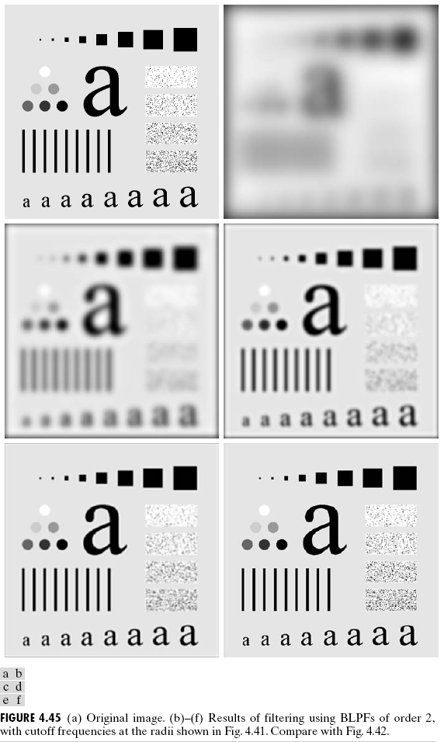

1. **(b)**

Fig. 5.31 Effect of various cutoff frequencies on (a) ideal low pass ideal filter and (b) low pass Butterworth filter.

It is seen that as the filter cutoff frequency increases, the image become more similar to the original image shown on upper left of Figures 5.31(a) and 5.31(b). Furthermore the effect of ringing has been much reduced using the Butterworth filter.

**Selectively Removing noise**

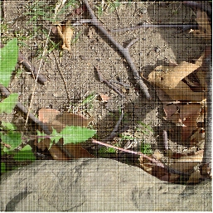 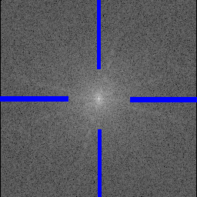 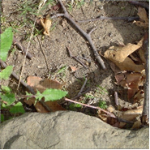

(a) (b) (c)

Fig. 32 (a) noisy image, (a) selectively removed frequencies, (c) filtered image

Figure (a) shows that the image has a mesh noise. The Fourier spectrum of the image is shown in (b) where blue band correspond to the noise in vertical and horizontal (blue bands). Fig (c) is obtained after the blue areas in (b) is set to zero and then the inverse transform is applied.

**5.7.5 Gaussian Low Pass Filter**

This filter also ensures smooth transition and thus has no ringing effects. It is described by

 (5.28)

The characteristics of this filter are shown in Fig. 5.32. In this figure and *D= r.*



***#v#############***

***u#***

***v#***

Fig. 5.32 Characteristics of the low pass Gaussian filter.

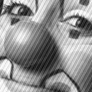 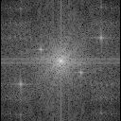  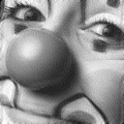

1. (b) (c) (d)

Fig. 33 (a) Noise corrupted image, (b) Fourier spectrum, (c) Guassian selective area filter, (d) image after filtering.

One important characteristic of this filter is that its spatial domain charateristics is also of Guassian form, i.e.

 (5.29)

An example of applying this filter is shown in Fig. 5.34 on a text with broken letters. It is seen that the filtered image is somewhat blur due to the nature of the low pass filter. However, it has joined broken letters.



Fig. 5.34 The effect low pass Gaussian filter on broken letters.

Fig. 5.34 show the effect of low pass Gaussian filter on smoothing and filtering out sharp changes.

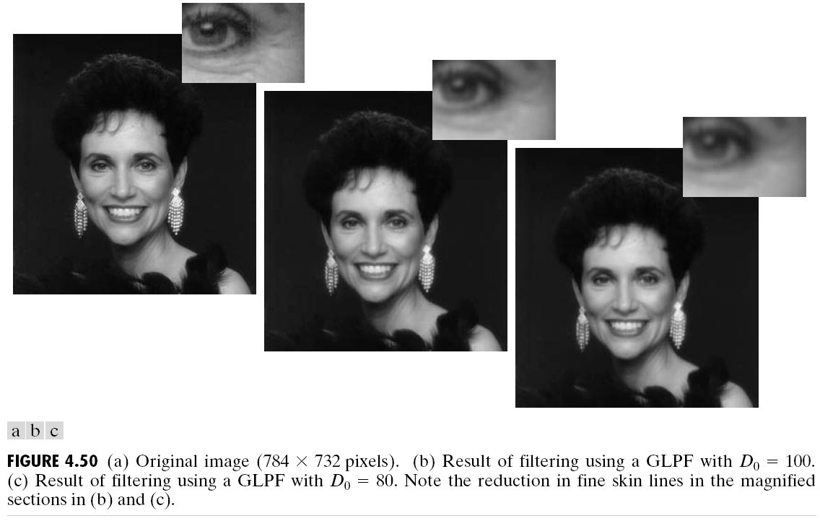

***###############***

Fig. 5.34. Smoothing using low pass Gaussian filter

**5.7.6 High Pass Filtering**

A high pass filter blocks low frequency components, and retains high frequency contents of an image. The ideal high pass filter is

 (5.30)

where and is  the cut-off frequency as before. As with the ideal low pass filter, this filter also gives rise to ringing, which can be avoided by the use of a Butterworth filter with the filter characteristics

 (5.31)

The characteristics of this filter is plotted in Fig. 5.35.

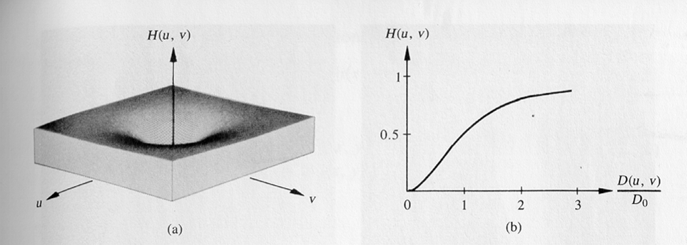

Fig. 5.35 Characteristics of high pass Butterworth filter.

The comparison between ideal and Butterworth high pass filters are shown in Fig. 5.36 and 5.37. It is observed that the ringing problem with the ideal filter has been remove using the Butterworth filter. Fig. 5.38 shows another example of high pass filtering.

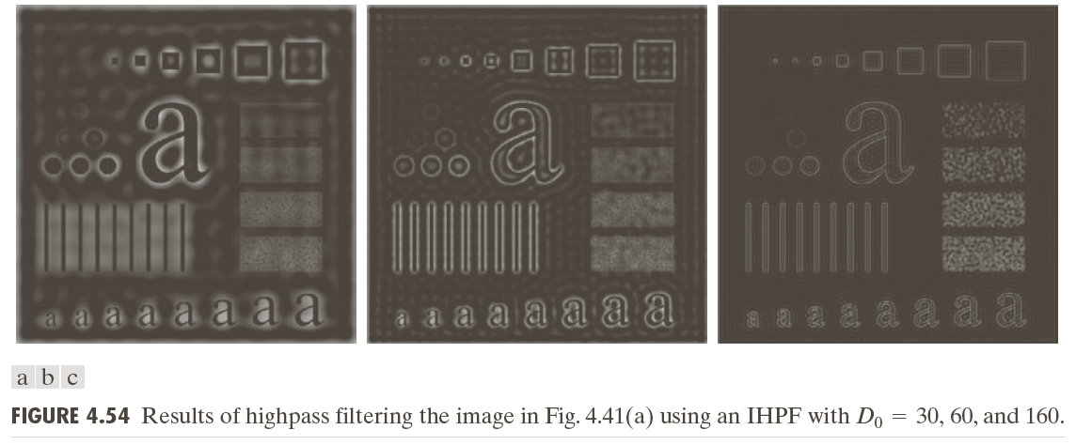

Fig. 5.36 Using ideal high pass filter produces ringing effect, =30, 60,160

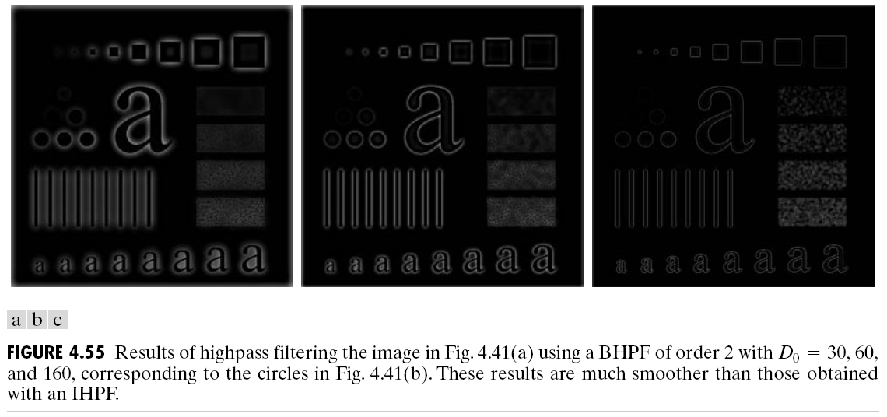

Fig. 5.37 Butterworth high pass filter of order 2 (p=2) with =30, 60,160.

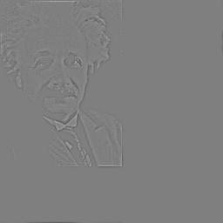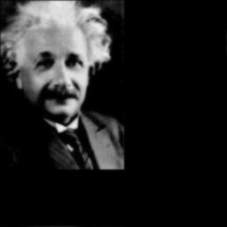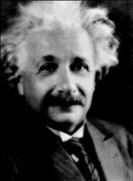

(a) (b) (c)

Fig. 5. 38 (a) original image, (b) low passed image, and (c) high passed image.

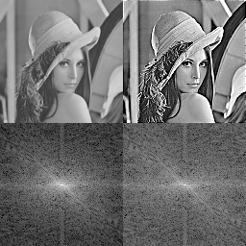

Fig. 5.39 High frequency emphasis – Sharpening

The Gaussian high pass filter is defined as



Its characteristics are shown in Fig. 5.40

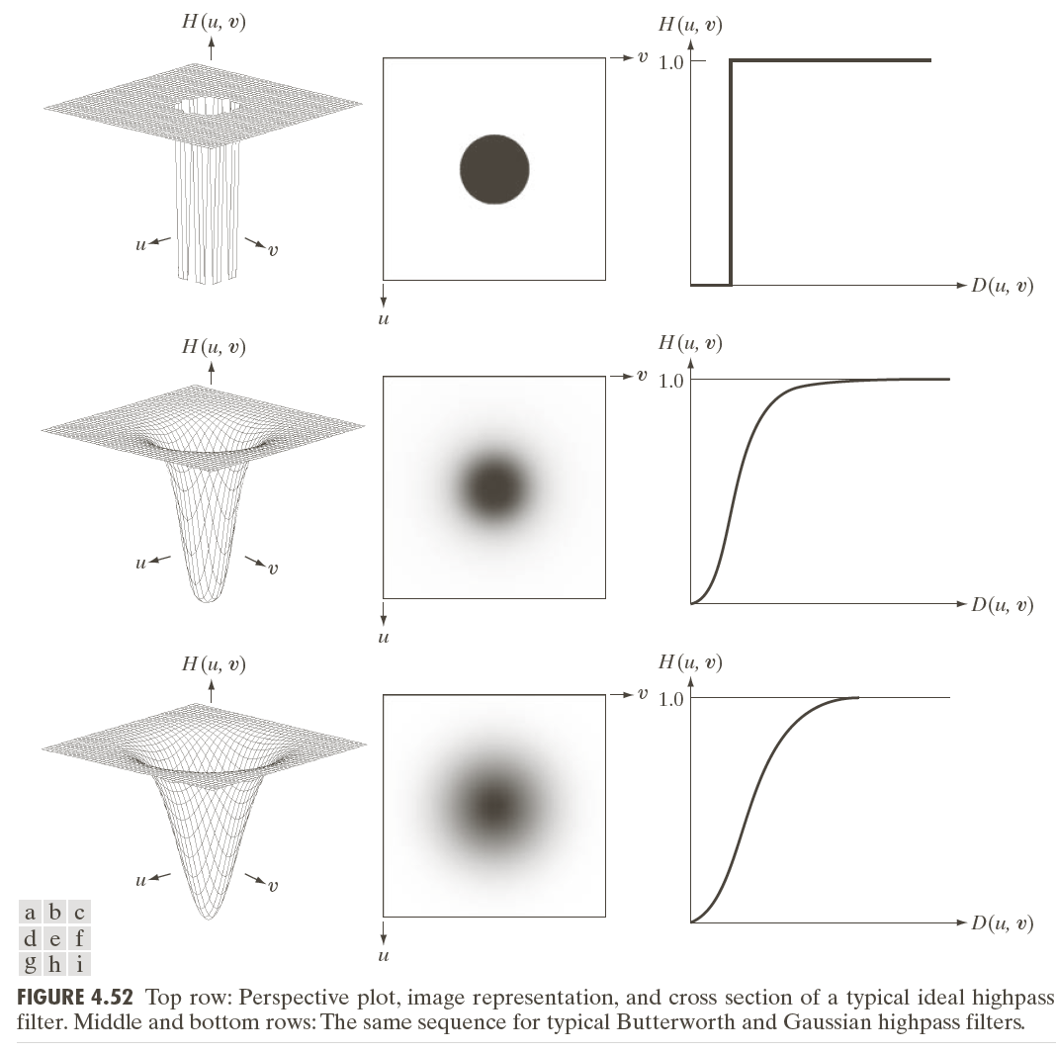

Fig. 5.40 Characteristics of the high pass Gaussian filter.

**Exercise**: Consider a filter that is *H(0,0)=0*, and *H(u,v)= 1* for *u,v = 1,2, …, n-1*.The original and filtered images are shown in Fig. 5.41. Explain the reason for obtaining Fig. 5.41 (b)

 

(a) (b)

Fig, 5.41 Filtering with a special filtter, (a) original inage, (b) high passed image.

**5.7.7 Band Pass and Band Stop Filters**

A band pass filter passes a specific range of frequencies, and rejects others. A band stop filter has the opposite characteristics, i.e. it rejects a specific range and passes all other frequencies. The transfer function of the band stop filter can be specified by a cutoff frequency and a bandwidth ***w*** as

 (5.34)

Note that at frequencies close to ,  approaches zero (why? and what is its value at *r* = w?). The band pass transfer function is

 (5.34)

(why is (5.34) a band pass filter?).

Fig. 5.42 shows an application of the band-pass filter.

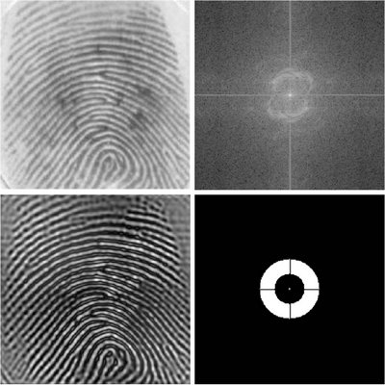

5.42 Band pass filter of finger print.

* + 1. **Implementation of Filters**

Let Pic.jpg be an image to be low pass filtered. Frist we define a circular filter Circle in frequency domain, then take the Fourier transform of the Pic which becomes Picfft. Subsequently, we multiply the Fourier transforms of the image and the filter elementwise (.*) to get FilteredPicfft and finally take the inverse to obtained the filtered image in spatial domain.

*>> [u,v]=meshgrid(-128:127, -128:127);*

*>> r = sqrt(u.^2+v.^2);*

*>> CircFilter =(r<20);*

*>> Pic=imread(‘picture.jpg’);*

*>> Picfft=fftshift(fft2(Pic));*

*>>FilteredPicfft=Picfft.*CircFilter;*

*>>imshow(mat2gray(log(1+abs(FilteredPicfft));*

*>>InverseFilteredPicfft=ifft2(FilteredPicfft);*

*>> imshow(mat2gray(abs(InverseFilteredPicfft))*

A low pass Butterworth filter of size 256 by 256 with the radius $r_{0}$ can be formed as

*>> [u,v]=meshgrid(-128:127, -128:127));*

*>> BwLPFilter=1./(1+((u.^2 + v.^2)/20).^2);*

The rest is as circular filter above. High pass ideal and high pass Butterworth filtered can similarly be implemented. For example the latter is found as

*>> BwHPFilter=1-1./(1+((u.^2 + v.^2)/20).^2);*